OTEL AUTO- INSTRUMENTATION
apiVersion: apps/v1
kind: Deployment
metadata:
name: {{ .Values.name }}
namespace: {{ .Values.namespace }} # observability-poc
labels:
app: {{ .Values.name }} # Do not add OTel annotation here

spec:
replicas: {{ .Values.replicaCount }}
selector:
matchLabels:
app: {{ .Values.name }}
strategy:
type: RollingUpdate
rollingUpdate:
maxSurge: 1
maxUnavailable: 1
template:
metadata: # Pod template level
labels:
app: {{ .Values.name }}
comprinno_application_group: comprinno # add comprinno labels
comprinno_environment: dev
comprinno_service: <service-name>
comprinno_cluster:<cluster_name>
annotations: # OTel annotation MUST be here (pod level)
instrumentation.opentelemetry.io/inject-java: observability-poc/otel-instrumentation
spec:
nodeSelector:
role: {{ .Values.nodeSelector.role }}
{{- if .Values.serviceAccountName }}
serviceAccountName: {{ .Values.serviceAccountName }}
{{- end }}
containers:
- name: {{ .Values.name }}
image: "{{ .Values.image.repository }}:{{ .Values.image.tag }}"
ports:
- containerPort: {{ .Values.containerPort }}
{{- if .Values.configmapref.name }}
envFrom:
- configMapRef:
name: {{ .Values.configmapref.name }}
{{- end }}
{{- with .Values.resources }}
resources:
{{- toYaml . | nindent 12 }}
{{- end }}
Annotation by Language

Python

instrumentation.opentelemetry.io/inject-python: "observability-poc/otel-instrumentation"
Node.js

instrumentation.opentelemetry.io/inject-nodejs: "observability-poc/otel-instrumentation"

Step 2 : Apply
kubectl apply -f <appdeployment.yaml>
Step 3 : Restart to trigger OTel injection
kubectl rollout restart deployment <deployment-service> -n <namespace>
Step 4 : Watch new pod
kubectl get pods -n <namespace>
Step 5 : Validate
Kubectl describe pod <pod_name> -n <namespace>
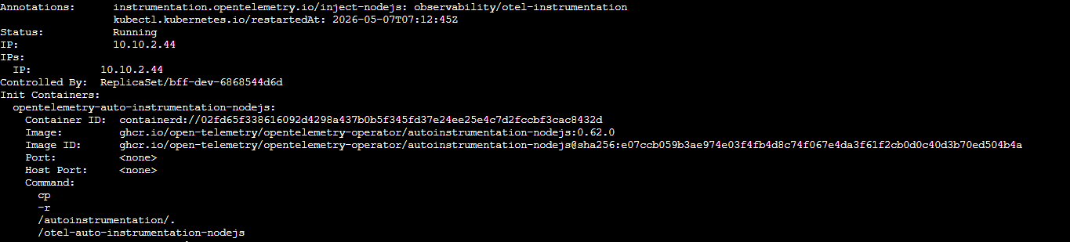
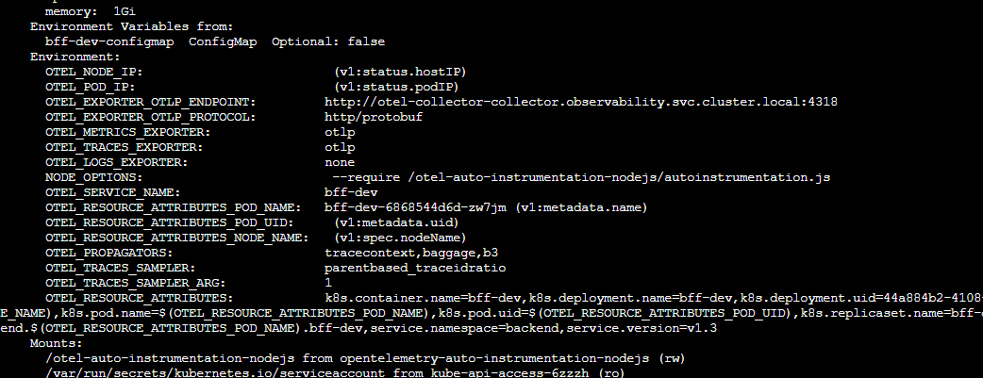
Oficial doc:
auto_instrumentation-link
